**Task 8: Identify and Remove Suspicious Browser Extensions.**

**Step 1:**

Choose and Sign up for Reputable Free VPN Service.

**Step 2:**

After completing the process of installing VPN Service checking the IP address using What is MyIPAddress.com .

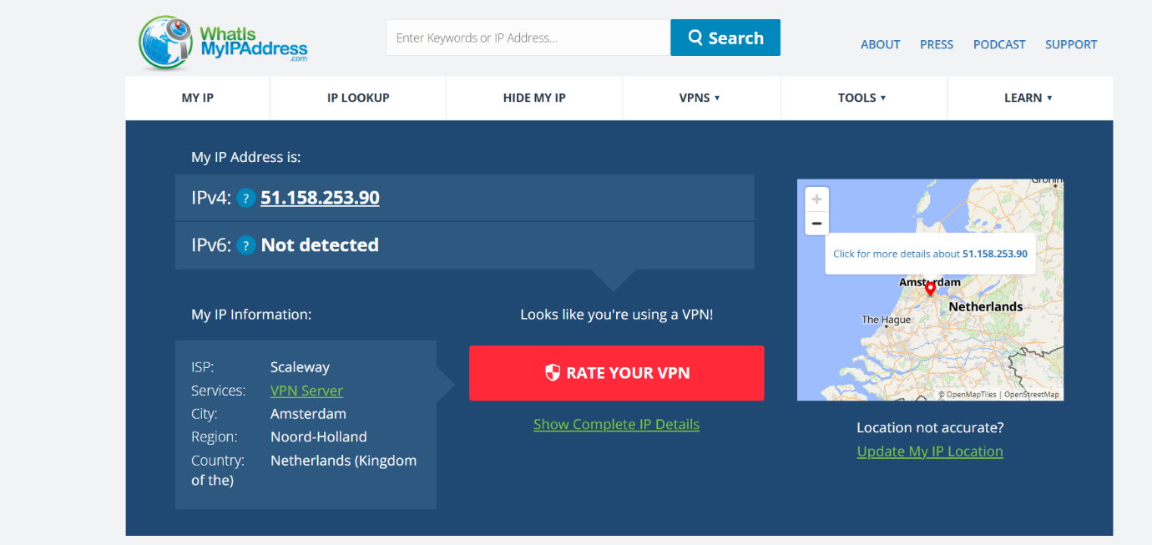

### [‎](https://github.com/Vasantha2127/Task-8/commit/37f5511ddb31e544ceaa14aed7a842c71ef1c531" \l "diff-3c089202a76108587aca29dec53251c88ecfcf7c823439e2ac36929002839167)

**Step 3:**

If VPN Service is ON then the IP Address cannot be detected.